The Structure & Convections of Earth’s Systems
Grade 10
May 3, 2023

In this article, we’ll learn about the structure & convections of Earth’s systems. Let’s begin.

Earth’s Structure
The Earth’s interior comprises several circular layers of which the crust, the mantle, the outer core, and the inner core are essential because of their distinctive physical and chemical characteristics.
The crust is a solid silicate, the mantle is in the form of viscous molten rock, the outer core is in the form of a viscous liquid, and the inner core is in the form of a dense solid.
Chemically, Earth is divided into the crust, upper mantle, lower mantle, outer core, and inner core.

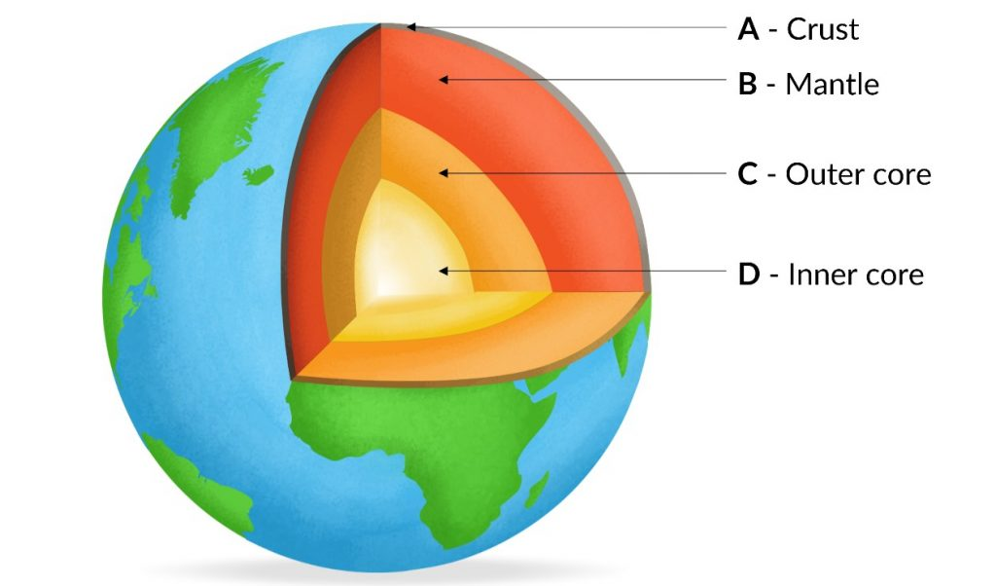 Earth’s structure (Chemical)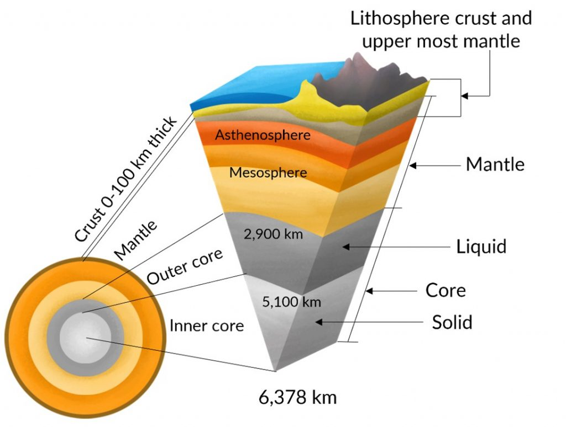 Earth structure (Physical or Mechanical)

Importance of Understanding Earth’s Interior Structure
Understanding the structure of the Earth’s interior, i.e., crust, mantle, core, and various forces such as heat and seismic waves radiating from Earth are essential to understanding –
- The development of the Earth’s surface, its existing shape, and future.
- Geophysical occurrences like volcanoes, earthquakes, etc.
- Earth’s magnetic field.
- The internal structure of various objects in the solar system.
- The development and present structure of the atmosphere.
- For mineral study.

Earth’s Surface
- Various geological activities shape the Earth’s surface.
- The forces affecting these activities come from above and below the Earth’s surface.
- Activities caused by forces from inside the Earth are called endogenous activities (Endo meaning “in”).
- Exogenous activities (Exo meaning “out”) occur from forces on or above the Earth’s surface.
- The major geological characteristics of the Earth’s surface, such as mountains, plateaus, and lakes, mainly arise from endogenous activities such as folding and faulting caused by forces from the interior of the Earth.

Geophysical activities like volcanoes, earthquakes, etc.
- The forces that cause disastrous incidents, such as earthquakes and volcanic eruptions, occur deep within the Earth’s surface. For example, earthquakes occur due to the movement of the tectonic plates, and the conventional currents in the mantle provide the energy needed to train tectonic plates.
- Similarly, volcanoes happen through the openings and cracks created by tectonic movements.

Earth’s Magnetic Field
- The temperature of the outer core varies from 4400°C in the outer core regions to 6000°C near the inner core region. Heat sources include energy given out by the compression of the core, the energy given out at the inner core border as it grows (the latent heat of crystallization), and radioactivity of elements, for instance, uranium, thorium, and potassium.
- The variation in temperature, pressure, and composition within the outer core produces convection currents in the molten iron of the external body. As it cools, dense matter sinks, whereas warm, less dense matter rises. This flow of liquid iron produces electric currents, which in turn create magnetic fields.
- Charged metal particles going through these fields keep creating electric currents of their own, and like this, the cycle goes on. This self-maintaining loop is called the geo-dynamo.
- The benefit of this magnetic field is that it protects the Earth from the Sun’s damaging solar wind.
• The outer core layer is essential because without this layer, Earth will not have a magnetic field, and without a magnetic field, Earth will not have life, ocean, and atmosphere on it.
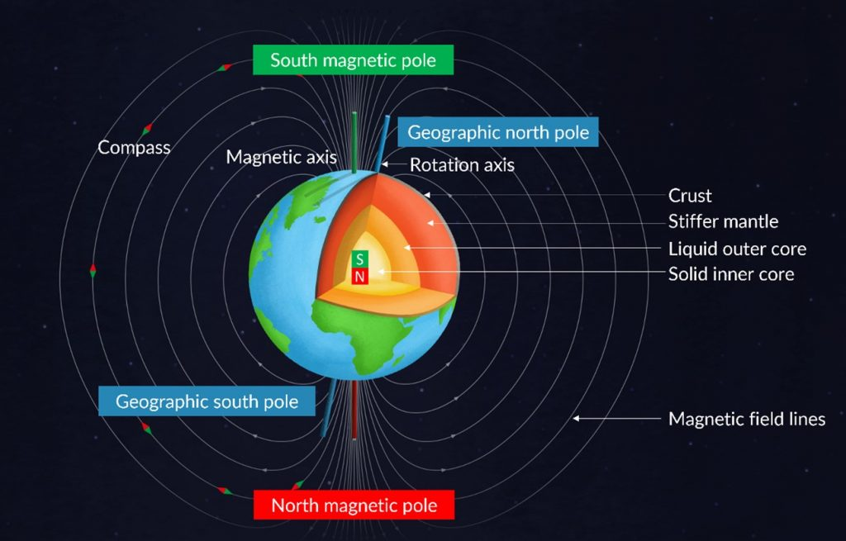 Earth’s Magnetic Field

The interior structure of different solar system objects
- The complete solar system was created from a single nebular cloud, and the process of the creation of every solar system object is supposed to be similar to that of the Earth.

Evolution and current composition of the atmosphere
- For life to prosper on the surface of the Earth, the atmosphere should have necessary elements such as oxygen for respiration, CO_{2,} and other greenhouse gases to control the temperature on the surface, ozone to protect life from harmful ultraviolet radiation, and the proper atmospheric pressure.
- All these components of the Earth’s atmosphere provide their presence to the volcanic eruptions that explain the Earth’s interior.

Direct Sources of Information about Earth’s Interior
- Mining
- Drilling, for example, Deep drilling of ocean
- Volcanic eruptions
Deep mining of Earth and drilling gives information on the nature of rocks deep down the surface.
Volcanic eruptions help in providing direct information about Earth’s interior.

Indirect Source of Information about Earth’s Interior
Increase in pressure and temperature with depth
The Earth’s diameter and gravitation help assess pressure deep inside the Earth.

Volcanic eruptions and the presence of hot springs, geysers, etc., give information about the Earth’s interior, which is extremely hot.
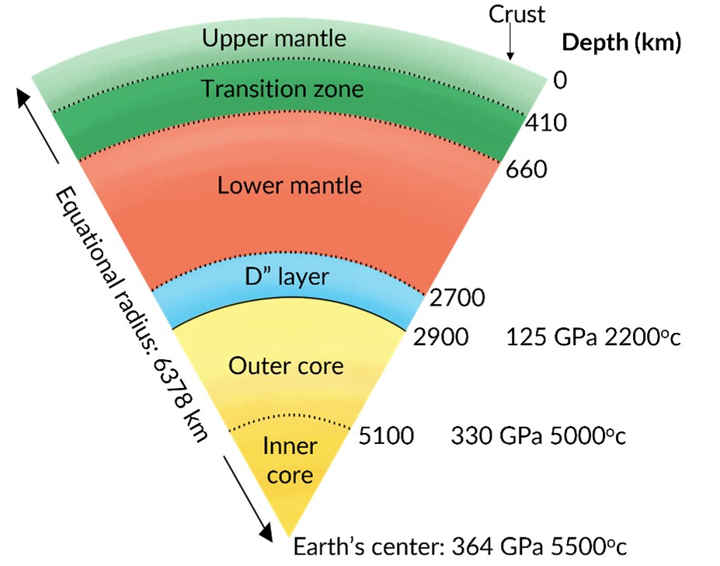 Temperature and depth in Earth’s interior

Seismic waves
One effective way scientists learn about Earth’s interior is by seeing the movement of energy from the point of an earthquake, called seismic waves. Seismic waves move outward from where the ground breaks down at an earthquake. Seismograph stations calculate the energy emitted by these earthquakes.
Two waves help to understand the interior of the Earth. The seismic waves calculated in mantle studies are known as body waves because these waves move through the body of the Earth. The velocity of body waves changes with density, temperature, and rock type.
The two types of body waves are P-waves, or primary waves, and S-waves, or secondary waves. P-waves are also called pressure waves, which are developed by compressions.

Primary waves (P-waves):
These are the fastest moving waves at about 6 to 7 km/sec (about 4 miles). Hence, they reach first at the seismometer.
P-waves move deep within the Earth’s interior and travel through both solid and liquid (through the whole Earth) mediums. P-waves travel straight. They expand and contract on their way. As a result, P-waves cause the most minor damage of all the waves.
As P-waves come across the liquid outer core, which is less rigid than the mantle, they slow down. This makes them arrive late and further away than would be anticipated. This results in a P-wave shadow zone. Hence P-waves cannot be picked up at seismographs 104o to 140o from the earthquake’s focus point.

Secondary Waves (S-waves):
The secondary waves are slightly slower (4-5 km/sec) than the P- waves. They arrive at a given location after the P-waves. S-waves travel deep within Earth’s interior but only move through solids (crust and mantle). They move up and down in an S-like motion and are more damaging than P-waves. S-waves cannot move through a liquid medium.
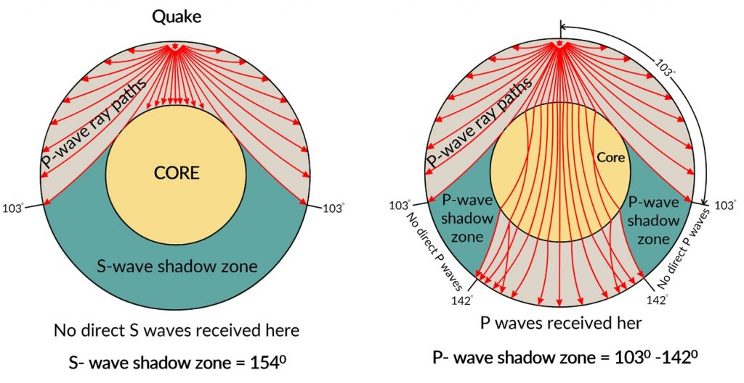 S wave and P wave
By following seismic waves, scientists can study Earth’s interior. P-waves slow down at the mantle core border, so we know that the outer core is less rigid than the mantle. S-waves disappear at the mantle core border, showing that the outer core is liquid.
Other hints about Earth’s interior include that the Earth’s total density is greater than the density of crustal rocks, so the core must be made of something dense material, such as metal. Also, since Earth has a magnetic field, a metal must be inside it.
For example, iron and nickel are both magnetic. Lastly, meteorites and Earth evolved from the same nebular cloud. Hence, they are likely to have the same internal composition.
When meteoroids fall to Earth, their outer layer is burnt during their fall due to severe friction, and the inner core is visible. The heavy material structure of their cores proves that the structure of the Earth’s inner core is the same.

Seismic Discontinuity
Seismic discontinuities are the areas on Earth where seismic waves act very differently than the surrounding regions due to a noticeable change in physical or chemical properties.

The Mohorovicic (Moho) discontinuity
Mohorovicic (Moho) discontinuity creates the boundary between the crust and the upper area of the mantle (asthenosphere), where there is a discontinuity in the seismic velocity.
It occurs at an average depth of about 8 kilometers under ocean basins and 30 kilometers underneath continental surfaces.
The basis of the Mohorovicic discontinuity (Moho) is thought to be a change in the chemical composition of rocks containing feldspar (above) to rocks that do not have feldspars (below).

Gutenberg Seismic Discontinuity / Core-Mantle Boundary
The Gutenberg discontinuity is also known as the core-mantle boundary (CMB). At the CMB, S-waves, which cannot travel in liquid, suddenly vanish, and P-waves are strongly bent or refracted. This notifies seismologists that the solid and molten formation of the mantle has given way to the blazing liquid of the outer core.

Lehman Seismic Discontinuity / The Inner Core
The transition zone between the outer and inner core is Lehman Seismic Discontinuity. The Lehmann discontinuity is a sudden increase of the P-wave and S-wave velocities at a depth of 220±30 km. Inge Lehmann, a seismologist, discovers it. It is present below continents but not usually below oceans.

Repiti Discontinuity
The transition zone between the outer and inner mantle is respite discontinuity.
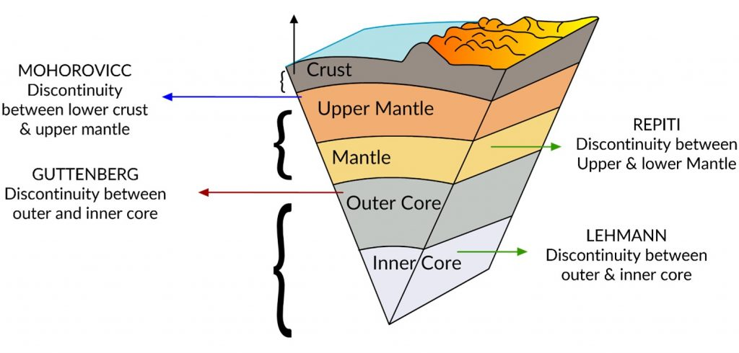 Mohorovicic discontinuity

Mantle
- The mantle is made up of rock; it is hot and is present below the crust. It expands up to a depth of 2900 km below the crust. The mantle is divided into the upper and lower mantle.
- Mantle mainly comprises silicate rocks that are rich in iron and magnesium. Olivine, garnet, and pyroxene are the common silicates found in the mantle. The mantle consists of constituent elements – 45% oxygen, 21% silicon, and 23% magnesium (OSM). • In the mantle, temperatures vary from around 200°C at the upper boundary with the crust to about 4,000°C at the core-mantle boundary.
- Because of the temperature difference, there is a circulation of convective material in the mantle (through solid, the elevated temperatures in the interior of the mantle cause the silicate material to be adequately ductile).
- In the mantle, rocks continuously move up and down due to internal heat from the core area, forming convective currents. The movement of tectonic plates shows the mantle’s convection at the surface. These currents cause rock plates to move and collide, resulting in earthquakes.
- The combination of the upper mantle and crust forms tectonic plates. These plates move very slowly. The point where plates touch each other is called a fault.
- The transfer of heat and material in the mantle helps to identify the landscape on the Earth. Activity in the mantle pushes plate tectonics to cause volcanoes, seafloor spreading, earthquakes, and mountain-building (orogeny).

Convections in the Mantle

Heat flows in two various ways inside the Earth:
Conduction: Heat is transferred through quick collisions of atoms, which can only occur if the material is solid. Heat transfers from warmer places to cooler places until all places have the same temperature. The mantle is hot mainly due to the conduction of heat from the core.
Convection: If a material can move, convection currents form even if it moves very slowly. Earth’s mantle is thought to be comprised of olivine-rich rock—the temperature of the rock changes at different depths. The temperature is lowest immediately below the crust and rises with depth. The highest temperatures are seen where the mantle material is connected with the heat-producing core.
This continuous rise of temperature with depth is known as the geothermal gradient. Different rock behaviors depend on the geothermal gradient, which splits the mantle into two distinct zones. Cool and brittle rocks are in the upper mantle, whereas hot and soft (not molten) rocks are in the lower mantle.
Brittle rock in the upper mantle can break under stress and produce earthquakes. But smooth stones in the more insufficient mantle flow when exposed to forces instead of breaking. The lower limit of the brittle behavior of rock is the border between the upper and lower mantle.
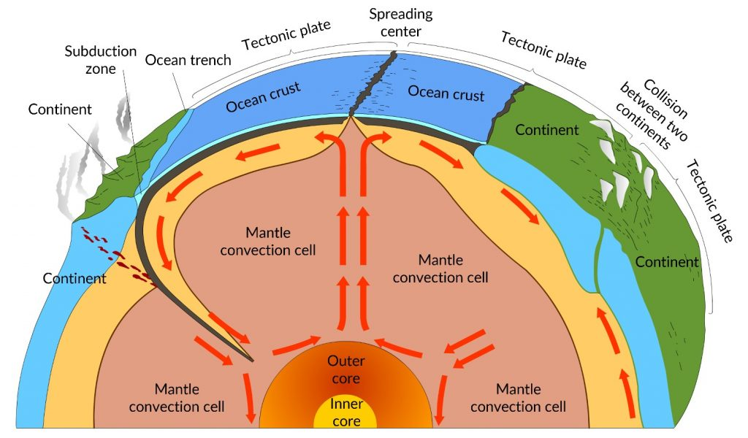 Convection in mantle

Asthenosphere
The asthenosphere (asthenic means weak) is the upper portion of the mantle. It is right below the lithosphere ranging up to 80-200 km.
The density of the asthenosphere is higher than that of the crust. In addition, it is ductile and mechanically weak. These characteristics of the asthenosphere help in the movement of plate tectonic and isostatic modifications (the elevated part at one part of the crust area is balanced by a depressed part at another crust area).
Asthenosphere is the primary magma source that reaches the surface during volcanic eruptions.

Models of Mantle Convection
For example, in the case of a soup bowl, hot soup from the bottom of the bowl to the top by convection. Some geologists think that even the process of Earth’s convection works similarly. That is — hot rock from the bottom of the mantle moves to the top before it gets relaxed and falls again. This entire process is called whole-mantle convection. Other geologists think that the upper and lower mantle are too varied to convect.
They point to slabs of lithosphere falling back into the mantle, some of which seem to settle on the boundary between the upper and lower mantle rather than falling straight through. They also noted chemical changes in the magma originating in various mantle areas. However, the changes are irregular, and the entire mantle is agitated.
They say that double-layered convection is well fit with the observations. However, other geologists say that there may be some spots where convection moves from the bottom of the mantle to the top of the mantle, and some groups of geologists say that it does not move.
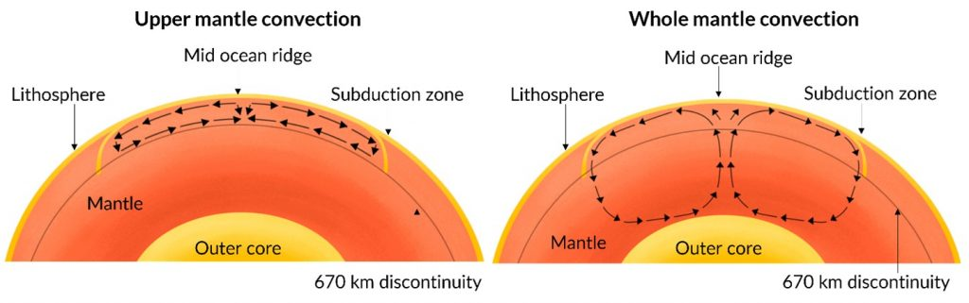 Mantle convections

Mantle Maps
Innovative technology has allowed geologists and seismologists to produce mantle maps. Most mantle maps show seismic velocities, showing patterns deep below the Earth’s surface.
Geoscientists hope that modern mantle maps can plot the body waves of as many as 6,000 earthquakes with magnitudes of at least 5.5. In addition, these mantle maps may detect early slabs of subducted material and the accurate position and movement of tectonic plates. Finally, many geologists think that mantle maps may even give proof for mantle plumes and their structure.
